About Us

The Santa Barbara Body Therapy Institute (SBBTI) is a private institution offering: vocational and avocation bodywork training, affordable student massage and professional bodywork. Our mission is to prepare students for professional practice in holistic massage, to provide an educational environment that fosters personal health, vitality and to provide a bridge between students and the community that educates, serves and promotes the therapeutic benefits of massage.



The Institute was founded in 1984 and ownership was transferred to Katie Mickey in October 1989. The school became incorporated in 1997 with full ownership remaining with Katie Mickey. Our programs include traditional styles of Swedish and Deep Tissue as well as more esoteric approaches such as Medical Qigong and Access Energy. Our graduates are successfully employed throughout the tri-counties in private practice, medical centers and spa settings as well as sharing their skills with families and friends.

**Santa Barbara Body Therapy Institute - School Performance Fact Sheet**

**Calendar Year 2012**

|  |  |  |
| --- | --- | --- |
| Program name:  Massage.. | Practitioner  250 hr | Therapist 550 hr |
| Enrollment: 1/1/12- 12/31/12 | 67 | 28 |
| Available to graduate by: 12/31/12 | 52 | 22 |
| Complete by 12/31/12 | 38 | 14 |
| Rate of Complete | 73% | 64% |
| Available for Employment | 24 | 12 |
| Working in field based on returns | 17 | 8 |
| Continue education  Based on returns | 15 | 4 |
| Placement rates | 71% | 67% |

**Annual Wages:**

**Practitioner** - 9 at $10 -15, 000…

1 at $15 - 20,000… 3 at $20 - 25,000…

2 at $35 - 40,000.. . 2 at $45 - 50,000.

**Therapist**  – 6 at $10 – 15,000…

1 at $20 – 25, 000.. . 1 at $50-55,000

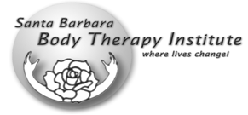

Santa Barbara Body Therapy Institute

516 N. Quarantina St.

Santa Barbara, CA 93103

(805) 966-5802

www.sbbti.com

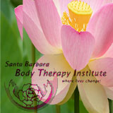

**Body Work Programs**

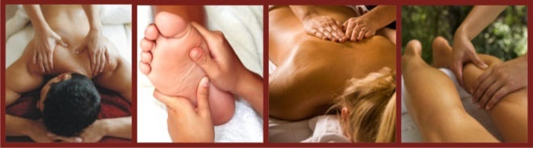

**Massage Practitioner Program**

**(250 hours)**

Our Massage Practitioner Program imparts essential methods for inducing relaxation, pain reduction and heightened states of peace and ease. The Practitioner Program comprises a foundational training in Swedish massage, seated massage, anatomy and physiology, body mechanics, movement, ethics and setting up practice as well as two additional bodywork modules of student’s choice of modalities.

**Massage Therapist Program**

**(550 hours)**

Our Massage Therapist program offers advanced bodywork training, preparing graduates to address a broad spectrum of musculoskeletal, visceral and nervous system imbalances. The Massage Therapist Program prepares graduates for employment in the high-end spa industry as well as private practice.

**Holistic Health Practitioner Program (1000 hours)**

Our Holistic Health Practitioner Program is designed for the serious student who desires to build a successful private practice. The HHP curriculum can be completed in roughly a one-year time frame, depending on rate of study. Students may also enroll in HHP courses on an “a la carte” basis. 1000 hour Holistic Health Practitioner Program is excessive in required hours to meet CAMTC certification requirements.

**Medical Qigong Practitioner Program**

**(200 hours)**

Our Medical Qigong Program offers training in energy work and Traditional Chinese Medicine. It is designed for the serious student interested in conducting a private practice in energy-based bodywork and self-healing exercises addressing general ailments and stress related conditions. Graduates will be granted a certificate of completion in Medical Qigong. Our MQP program is recognized by the International Institute for Medical Qigong. Our 200 hour Medical Qigong Practitioner Program is deficient in required hours to meet certification requirements per CAMTC.



**Medical Qigong Therapist Program**

**(500 hours)**

Our Medical Qigong Therapist Program offers advanced training in energy work and Traditional Chinese Medicine. It is designed for the serious student interested in addressing chronic and severe ailments and pathologies. Graduates will be granted a certificate of completion for Medical Qigong Therapist. Our MQT program is recognized by the International Institute for Medical Qigong. Completing the MQP program is prerequisite for attendance in MQT modules.

**A La Carte Program**

Students may also enroll in any of the modules on an individual basis. We are a NCBTMB Continuing Education Approved Provider and our continuing education is also accepted by CA Board of Registered Nursing.

We currently offer the following courses.

|  |  |
| --- | --- |
| Acupressure  Barefoot/Sports  Business Skills  Clinical Pathology  Craniosacral  Essential Oils  Five Elements  Nutrition  Lymphatic Drainage  Medical Qigong | Muscle Physiology  Myofascial Release  Pregnancy Massage  Reflexology  Shiatsu  Spa Deep Tissue  Swedish/ Ethics  Touch For Health  Trigger Point  Tui Na |

Please contact us for more information on upcoming courses and schedules, or visit us online at:

[**www.sbbti.com**](http://www.sbbti.com)

**805.966.5802**